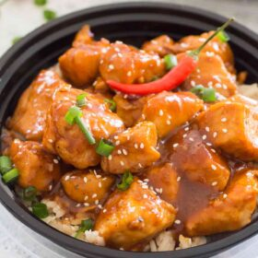
Spicy Bourbon Chicken
Prep time 10 min Cook time 15min
4 Servings
Ingredients
2 tbsp sesame oil or canola oil
1 lb chicken breasts or thighs
4 cloves garlic, minced
1 tsp fresh ginger, minced
¼ tsp crushed red pepper flakes
½ tsp chili powder
¼ cup low sodium soy sauce
¼ cup brown sugar
¼ cup bourbon
1 tbsp rice wine vinegar
¼ cup apple juice
1 tbsp ketchup
1 tbsp cornstarch
1 tbsp apple juice or water
Directions
- In a medium bowl combine soy sauce, brown sugar, bourbon, rice wine vinegar, apple juice and ketchup. Stir well and set sauce aside.
- Cut the chicken into 1-inch cubes.
- Add sesame oil to a large skillet or wok and heat it over medium-high heat. Cook the chicken and sauté until browned.
- Then, add in garlic, ginger, red pepper flakes and chili powder. Sauté for 1 minute.
- Pour the sauce into skillet with the chicken and bring to a simmer. Cook for about 4 to 5 minutes.
- In a small bowl whisk together cornstarch and apple juice (or water) and slowly add to the sauce. Stir frequently until thickened about 3 to 4 minutes.
- Serve immediately over rice or noodles, garnished with sesame seeds and green onions.

